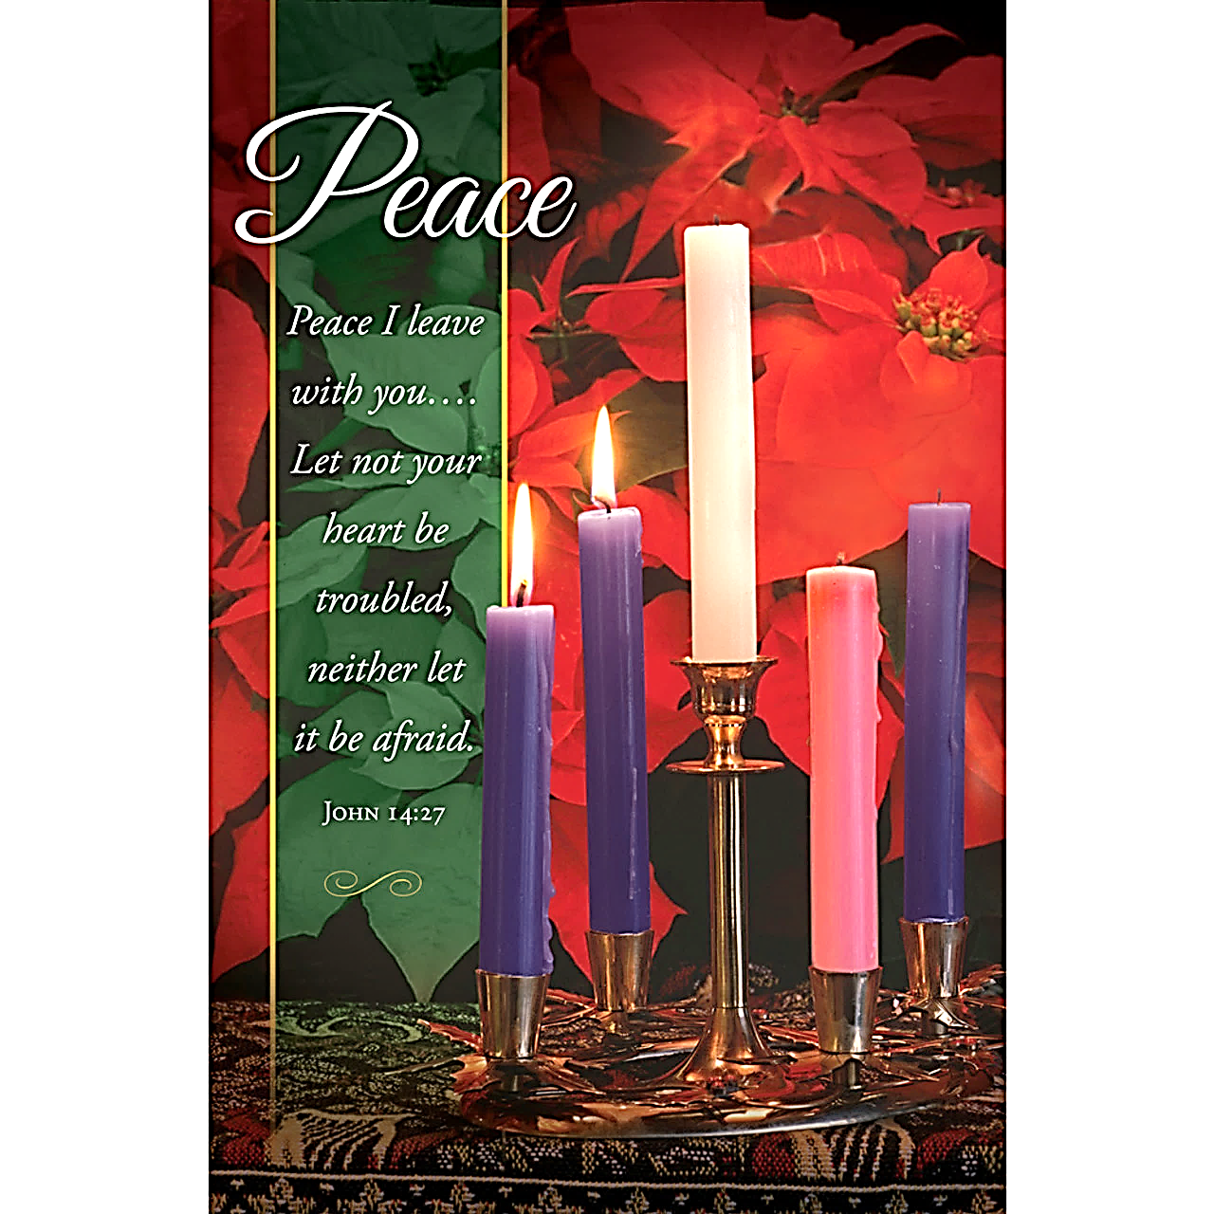
Haven United Methodist Church
Pastor ~ Rev. Juhee Lee
200 Taunton Avenue, East Providence, RI 02914
Phone: 401-438-4911/ Fax : 401-434-0289
www.havenumchurch.com ~ havenumchurch@yahoo.com
Pastor’s Office Hours: Tues, Wed, Thurs & Sat – 9:30am–12:30pm and by appt.
Church Office Hours: Mon – Wed 9:30am-4:30pm, Thu. 9:30am-2:30pm
Morning Worship 9:30am December 10, 2023
Second Sunday of Advent

GATHERING Sugie Jung
SPECIAL MUSIC “Christmas Medley”
Violin: Sabrina Chiang, Juhee Lee, Daniel Shin; Cello: Jay Baylon
GREETING Stacey Erickson
LIGHTING THE ADVENT WREATH Stacey & Scott Erickson
Stacey: In days when God’s people longed for peace, Isaiah declared, “Comfort, O comfort my
people, says your God. Speak tenderly to Jerusalem, and cry to her that she has served her
term, that her penalty is paid, that she has received from the Lord’s hand double for all her
sins.” (Isaiah 40:1)
Scott: We who gather today also seek comfort and peace, yet we are unsatisfied with ideas of
peace that tell us to keep quiet and go with the flow. We long for real peace, true peace, just
peace.
Congregation: We wait as people who yearn for peace that bears the fruit of community,
equity, and flourishing for all.
Stacey: We light these candles as signs of God’s shocking hope and just peace. May they be
beacons calling us to repent and to live the good news of Jesus Christ as we wait and watch
and labor for the day when all people can gather together to worship and glorify God. Amen.
Light two purple candles of the Advent wreath.
*MISSION STATEMENT: We are a haven for those who would seek to know God better while
spreading the love of Jesus Christ.
*CALL TO WORSHIP ministrymatters
L: In the middle of dark times, our Lord cries out:
P: “Comfort, comfort my people!”
L: When it seems as though we cannot see the light at the end of the tunnel,
P: Our Lord says to us, “Be at peace, for your time of difficulty has ended.”
L: Lord, we await the time of comfort and peace!
P: Lord, we are thankful for your compassion and never-failing love for us. AMEN.
*INVOCATION (in unison) ministrymatters
Lord, in the midst of our busy time, when we are in the rush to Christmas, you burst into our lives with the tantalizing promise of something new. Open our hearts and spirits to the glorious possibilities of hope and peace to come. Help us to prepare our lives to receive you. We thank you for all the blessings you pour on us and for the privilege we have in sharing these blessings with others. Be with us all this day and all these days that we may serve you better by helping others in need. In Jesus’ Name, we pray.
*OPENING HYMN “Angels We Have Heard on High” UMH 238
ANNOUNCEMENTS / CELEBRATIONS AND CONCERNS
SPIRIT SONG “My Tribute” UMH 99
PASTORAL PRAYER Rev. Juhee Lee
THE LORD’S PRAYER (in unison)
CHORAL RESPONSE TO PRAYER “Hear Our Prayer, O Lord”
Hear our prayer, O Lord; hear our prayer, O Lord; Incline Thine ear to us, and grant us
Thy peace. Amen.
VIRTUAL PASSING OF THE PEACE
L: The Peace of Christ be with you.
P: And also with you.
*HYMN “Shalom to You” UMH 666
YOUTH SERMON Rev. Juhee Lee
WORSHIP IN GIVING “O Come, O Come, Emmanuel" Sugie Jung
*DOXOLOGY
Praise God, from whom all blessings flow; praise him, all creatures here below;
praise him above, ye heavenly host; praise Father, Son, and Holy Ghost. Amen.
*OFFERTORY PRAYER Rev. Juhee Lee
*SCRIPTURE Gospel: Mark 1:1-8
L: ¹ The beginning of the good news of Jesus Christ.
P: ² As it is written in the prophet Isaiah, “See, I am sending my messenger ahead of
you, who will prepare your way,
L: ³ the voice of one crying out in the wilderness: ‘Prepare the way of the Lord; make his paths
straight,’ ”
P: ⁴ so John the baptizer appeared in the wilderness, proclaiming a baptism of
repentance for the forgiveness of sins.
L: ⁵ And the whole Judean region and all the people of Jerusalem were going out to him and
were baptized by him in the River Jordan, confessing their sins.
P: ⁶ Now John was clothed with camel’s hair, with a leather belt around his waist, and
he ate locusts and wild honey.
L: ⁷ He proclaimed, “The one who is more powerful than I is coming after me; I am not worthy
to stoop down and untie the strap of his sandals.
P: ⁸ I have baptized you with water, but he will baptize you with the Holy Spirit.”
L: This is the Word of God for the people of God.
P: Thanks be to God!
RESPONSE SONG
Let the words of my mouth, and the meditations of my heart, be acceptable in thy
sight, O Lord. Amen.
SERMON “What does it mean to prepare the way of the Lord now?” Rev. Juhee Lee
*CLOSING HYMN “The First Noel” UMH 245

*BENEDICTION Rev. Juhee Lee
Prepare the paths for the One who brings salvation and reconciliation in this world. May the repentance lead us to a renewal of spirit and a deep connection with the Holy Spirit. May God empower you to make peace, embracing the transformative power of Christ's love. As we await the arrival of the Savior, may you find joy in the anticipation, peace in your convictions, and strength in your life. May the power of God our Creator, Christ our Savior, and the communion of the Holy Spirit be with us now and forever. Amen.
* Those that are able, please stand.
VISITORS: Please introduce yourself to Pastor Juhee. We are glad you were able to join us today!
ANNOUNCEMENTS
WORSHIP SERVICES – view on our Facebook and YouTube pages!
BIRTHDAYS – Thomas Sargent – 12/12
Birthday Poem - We honor the day of your birth. God created you out of light and love. You are of
sacred worth, and reflect the very image of God. May God continue to bless and keep you.
COFFEE HOUR – We need VOLUNTEERS to host Coffee Hour every Sunday. Please see Delores to sign up.
ADOPT-A-FAMILY – We currently have one Afghan refugee working to settle down in the U.S., along with two families in our community. We will provide further updates on their situations soon. If you have any questions, please feel free to contact Stacey Erickson.
CHRISTMAS CONCERT – The Christmas concert went well and raised $1063 to support Healing Guatemala. This means we can now provide free cataract surgery for at least 17 people in Guatemala. Thank you all for your prayers and support!
LITURGIST SCHEDULE –12/17 – Dillon, 12/24 – Scott, 12/31 – Clarence, 1/7 – George, 1/14 – Chris
CHRISTMAS EVE WORSHIP 12/24/2023 4:00pm – Regular worship at 9:30am and a special worship service at 4:00pm. Join us for a special puppet show featuring various musical performances to celebrate Christmas. Please, invite your family and friends to share in the joy of Christmas!
CHRISTMAS POINSETTIAS - See Delores if you would like to order poinsettia(s) for the altar for Christmas. Choose RED or WHITE. Last day to order is December 17th. Cost is $7.00 each.
PRAYER REQUESTS:
Karen Miller and her son Austin Winkie Chrystie
Steve & Debbie’s granddaughter Alyson and son-in-law Mario
Ruth Sprigg Rev. Emmalou Kirchmeier Steve & Debbie
Ada Beebe Gloria Cady Bob Macedo
Romauld Paul Joan Chase Alice Dorbor
Manny Fernandes Rev. Althea Arthur Pomfret
Earnest Cox Donna Marshall Tim Marshall
Joey Zamorno Debbi & Kevin Joe Buoranduci
Dawn Thompson Joan & Family Carol Mitchell
Joseph Thomas Hank & Doris Greene Lane
Ilaisa Damuni Steve Furze George Glover
Scott Erickson
Sharing your love and encouragement with them through cards or phone calls would be appreciated.

